MPSG FINAL EXTENSION REPORT
Enhancing Manitoba Soybean Yield and Quality Under Sub-Optimal Conditions
PROJECT TITLE:
PROJECT START DATE: 1 April 2014 | PROJECT END DATE: 31 March 2018
DATE SUBMITTED: 9 March 2018

PART 1: PRINCIPAL RESEARCHER
PRINCIPAL
NAME: | Ramona Mohr
POSITION: | Research Scientist
INSTITUTION: | AAFC - Brandon
EMAIL: | ramona.mohr@agr.gc.ca
PHONE: | 204-578-6556

PART 2: EXECUTIVE SUMMARY
Outline the project objectives, a summary of the activities and results, and their relevancy to pulse and soybean farmers.

Small plot experiments were conducted for a total of 7 site-years at Carberry and Portage from 2014 through 2017, inclusive. The effect of rainfed, deficit and excess moisture conditions on root rot, yield and quality of nine soybean cultivars was assessed, with the aim of determining if variability existed among soybean cultivars adapted for Manitoba in terms of their tolerance to moisture extremes later in the growing season (from July through harvest).
Research findings suggested that established soybeans were relatively tolerant of excess moisture but less tolerant of moisture deficits later in the growing season. Soybeans grown under excess moisture consistently yielded the same as (4 of 6 site-years) or better than (2 of 6 site-years) under rainfed conditions despite the fact that excess moisture treatments received from 108 to 779 mm more water than rainfed treatments from July through harvest, and had been irrigated until chlorosis was evident in the soybean crop. In contrast, withholding water later in the growing season reduced soyean yield in 4 of 6 site-years by an average of 16% to 32% compared to rainfed conditions. Rainshelters prevented any rainfall on the soybean crop from July through fall such that deficit treatments received from 24% to 45% of the rainfall that rainfed treatments did. Although there appeared to be some variability among cultivars in their response to moisture conditions, effects did not appear to be consistent across site-years. Higher root rot severities where soybean was under moisture stress, either excess or deficit moisture, may have contributed in part to yield differences but effects were not consistent.

PART 3: EXPERIMENT DESCRIPTION & RESULTS
Experimental methods:
A series of field studies were initiated at Carberry (Canada-Manitoba Crop Diversification Centre, 2015-17) and Portage la Prairie (Agriculture and Agri-Food Canada, 2014-17) to assess the effect of later-season moisture conditions on soybean performance. At each site, a factorial combination of three moisture regimes (reduced, rainfed, excess) and nine soybean cultivars was arranged in a split-plot design with four replications. To produce three moisture regimes, main plots were either covered with rainout shelters (reduced moisture), irrigated such that soybean plants began to show chlorosis (excess moisture), or left uncovered and unirrigated (rainfed) (Figures 1 and 2). The various moisture regimes were typically imposed from July through until fall.
The same set of nine cultivars was grown in each site-year, with the exception of Portage in 2014 which included only seven of the nine cultivars. The cultivars in this study were selected based on root rot data from ongoing studies conducted by Dr. Debbie McLaren (AAFC-Brandon), such that the cultivars grown represented cultivars that varied in their response to soybean root rot. Cultivars were otherwise selected to be as similar as possible. In all cases, midseason, Roundup Ready cultivars, rated as semi-tolerant to tolerant for iron deficiency chlorosis were selected. Preference was given to those cultivars occupying relatively larger acreages based on Manitoba Agricultural Services Corporation data.
Soybean root rot severity, yield and quality were assessed in all treatments. Nearby weather stations provided precipitation and air temperature data. Soil moisture and temperature were recorded in each moisture treatment at 15 minute intervals using self-logging sensors (5TM Moisture and Temperature Sensor with Decagon EM50 logger).

Results to date:
Root rot severity varied among cultivars and among moisture regimes. Frequently, root rot severity was higher under both excess and deficit moisture conditions, with lower ratings frequently observed under rainfed conditions. These results suggested that plant stress, whether due to moisture excess or deficit, may contribute to the development of soybean root rot. While higher disease severity ratings were sometimes associated with lower yields, effects were not consistent among site-years and treatments, suggesting that factors other than soybean root rot severity may have contributed to the yield differences observed in this study.
Significant yield differences were evident among moisture treatments in 4 of 6 site-years, with soybean generally demonstrating a greater tolerance to moisture excess than deficit treatments (Figure 3). While moisture deficit consistently produced lower yields than either excess or rainfed treatments, in no site-year did the excess moisture treatment result in a significant overall yield decline compared to the rainfed treatment. In fact, yield increases were associated with excess moisture treatments in 2 site-years. In all cases, irrigation had been applied to the excess treatment (up to 779 mm more water than rainfed treatments, depending upon the site-year) until chlorosis was visible in the soybean crop, as physical confirmation that the crop had been stressed. In the case of moisture deficit treatments, soybean yields were 75%, 84%, 68% and 74% that of the rainfed treatments at Carberry 2015, Carberry 2017, Portage 2015 and Portage 2017, respectively. These deficit treatments received the equivalent of 24%, 37%, 27% and 45% of the rainfall in the rainfed treatments, with no rainfall from July forward.
While there appeared to be some evidence of variability among cultivars in terms of their yield responses under moisture stress, effects were not consistent among site-years based on the current analysis. A significant interaction between cultivar and moisture regime was measured in only 1 of 6 site-years, suggesting that cultivars generally responded similarly to varying moisture conditions, although more detailed contrast analysis revealed differences among select cultivars in their response to deficit and excess moisture in select cases.

Concisely describe the experimental methods and results to date. You may include up to 3 graphs/tables/pictures in the Appendix.

PART 4: RELEVANCE TO FARMERS AND FUTURE RESEARCH
The information generated from this project regarding the effect of moisture conditions on soybean root rot, yield and quality provides empirical data regarding the relative tolerance of locally-adapted soybean to a range of moisture conditions. The identification of increased soybean root rot severity under both moisture deficit and excess in this study suggests that potential exists for root rot development when the crop is stressed, and not only under conditions of excess moisture. While research findings confirm existing on-farm experience in terms of soybean's tolerance to excess moisture, these findings provide empirical data as to the degree to which established soybean is able to tolerate moisture later in the growing season, and also of its apparent ability to recover from moisture stress. Further, the impacts of moisture deficit later in the growing season have also been quantified.

While a standard approach to statistical analysis has been taken for the purposes of this report in order to identify treatment effects, potential exists to explore this dataset more fully going forward in order to determine potential linkages between detailed soil temperature and moisture data collected over the course of the growing season, the incidence and severity of soybean root rot, and soybean yield and quality. This dataset is unique for Manitoba in that it includes a range of cultivars with varying degrees of susceptibility to soybean root rot that were grown in the same field and under the same general environmental conditions, but exposed to different moisture stress conditions. Together, these data may help to contribute to a better understanding of those factors driving root rot and yield under Manitoba conditions.
Describe how the project results can be captured to benefit pulse and soybean farmers (production recommendations, innovation items, marketing plans, commercialization of technology etc). Identify any future research opportunities.
PART 5: COMMUNICATION
Over the course of the project, information was presented at field days at the Canada-Manitoba Crop Diversification Centre at Carberry and AAFC-Portage, in annual reports for the Diversification Centres, and in annual reports submitted to the Manitoba Pulse and Soybean Growers. This study was included as a tour stop for the 2017 Soybean Smart Day (July 19, 2017) at Portage la Prairie.
List extension meetings, papers produced, conference presentations made, project materials developed.

APPENDIX
Include up to 1 page of tables, graphs, pictures.

.
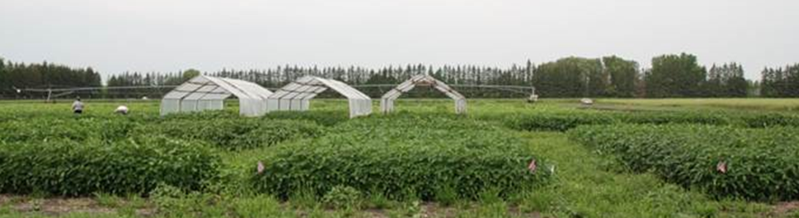
Figure 1. Field experiment following installation of rain shelters. (Photo courtesy of Debbie McLaren.)

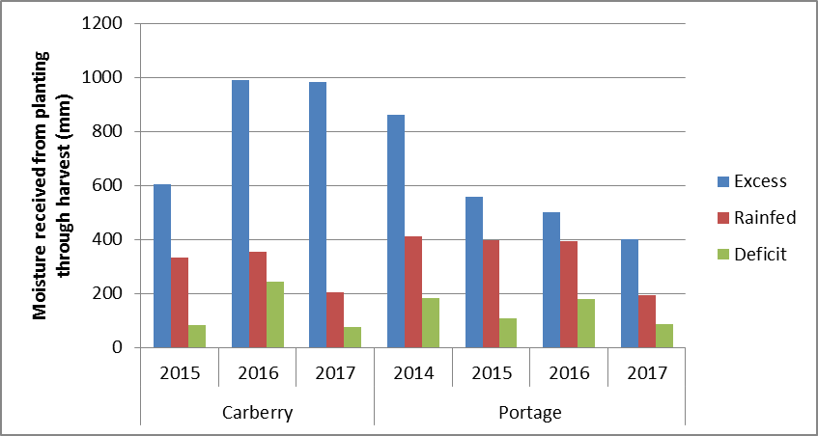
Figure 2. Moisture (rainfall in deficit and rainfed moisture treatments; rainfall+irrigation in excess moisture treatments) received by the soybean crop from planting through harvest at Carberry (2015-17) and Portage (2014-17).

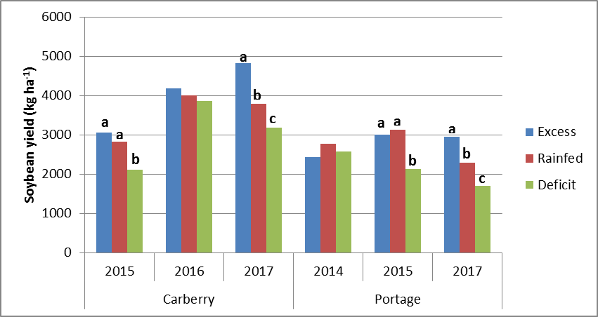
Figure 3. Soybean yield as affected by moisture regime (excess, rainfed, deficit) at Carberry (2015-17) and Portage (2014, 2015, 2017). (Due to hail damage at Portage in 2016, yield data could not be collected.) Soil moisture treatments within a site-year with the same letter are not significantly different based on Tukey’s multiple comparison procedure. A significant cultivar x moisture interaction was evident only at Carberry in 2016.

